UC DAVIS PATH TO NET ZERO WASTE FEASIBILITY REPORT
Alessandra Arif
Alexander Liesegang
Eavan Swanson

Prepared for the UC Davis Office of Sustainability
June 8th, 2026

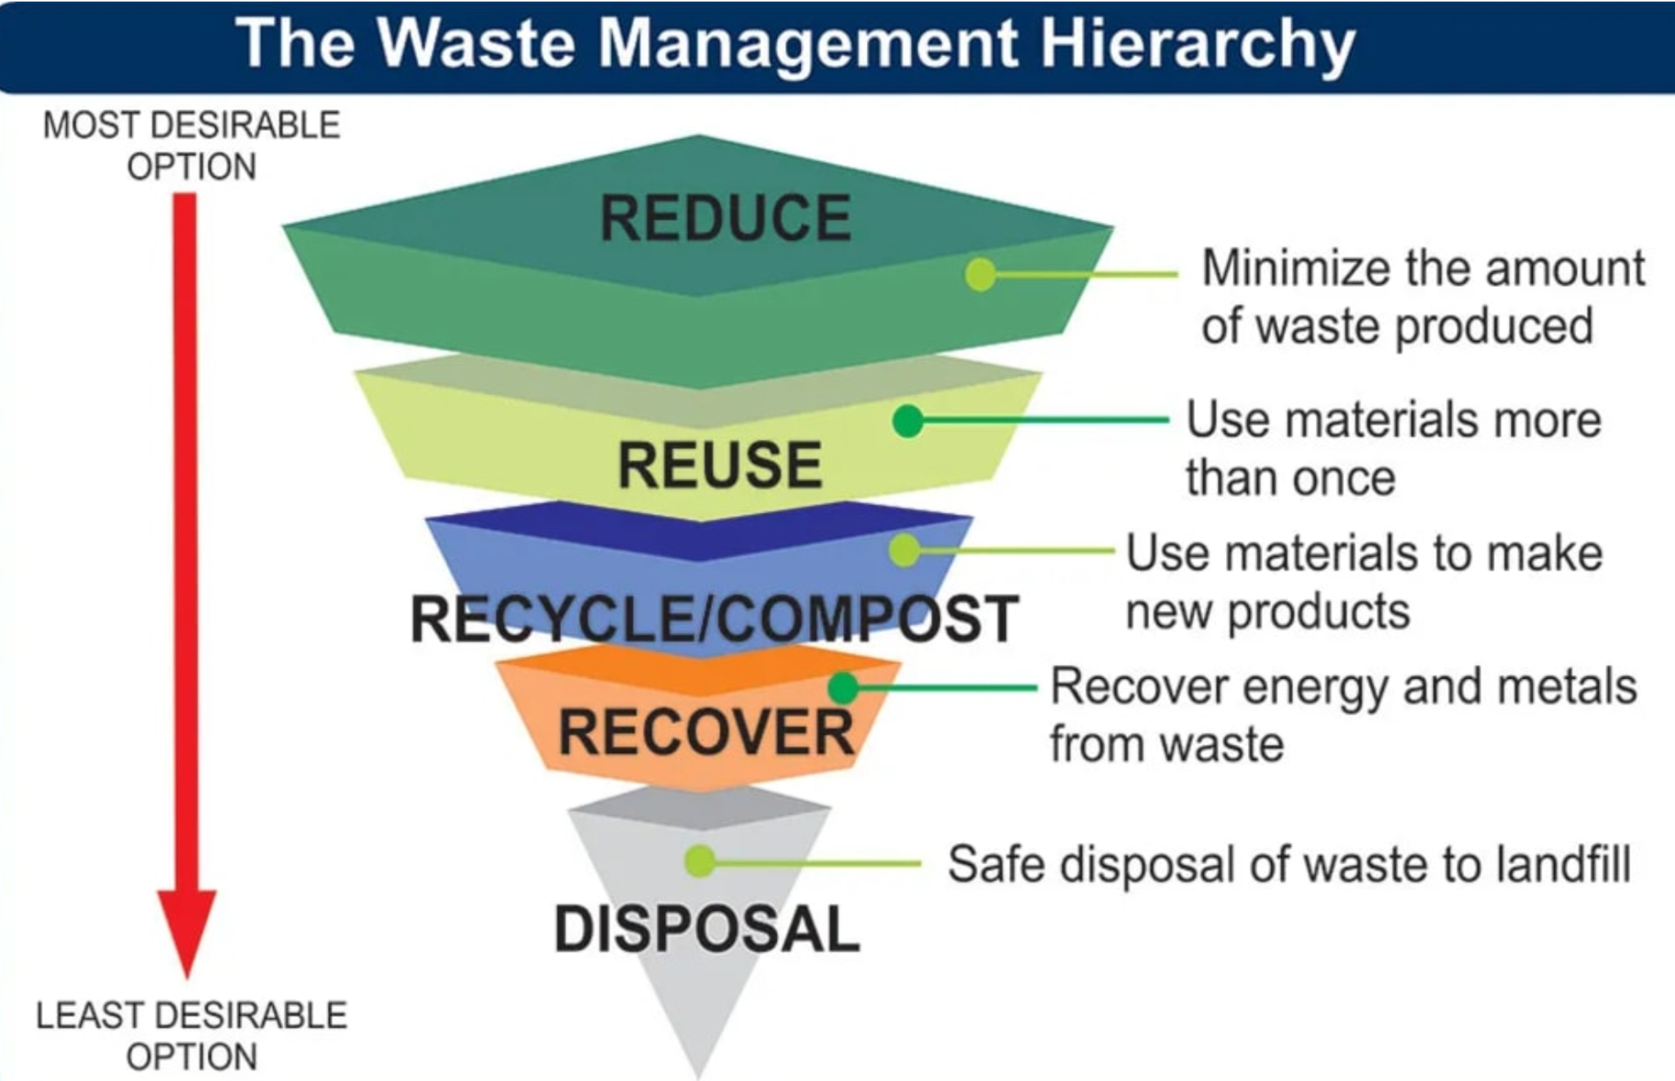
Executive summary
A key part of reducing the University of California, Davis' (UCD) greenhouse gas emissions (GHG) is reducing the amount of waste that the university generates in the first place. We have identified a myriad of promising methods for reducing on-campus waste generation, including increasing coordination among departments and hiring a zero-waste manager, gathering more data on which food items are most commonly discarded to better match supply to demand, and dedicating more resources to expanding reduction infrastructure and pilots so that reuse is easy and accessible.

Figure 1. The Waste
Management Hierarchy

Problem Context and Background
UCD generates about 1.43 pounds of waste per person each day (University of California Office of the President, 2025). UCD missed its goal of lowering its waste per capita to 0.91 pounds per day by 2025 (University of California Office of the President, 2025). Thus, this report was commissioned by Eric O'Brien and Kelli Ann O’Day with the UC Davis Office of Sustainability to identify potential ways to reach UCD’s reduction target. As it stands, UCD needs to reduce overall campus waste generation by about 36% to meet the now-passed UCOP goal of reducing waste by 25% below fiscal year 2015–16 levels by 2025 (University of California Office of the President, 2025). Reaching this goal is becoming increasingly challenging as per capita generation trends upwards.

Figure 2. Progress Towards Reduction of Per Capita Municipal Solid Waste Generation Across the UC System (University of California, Davis, 2025b).
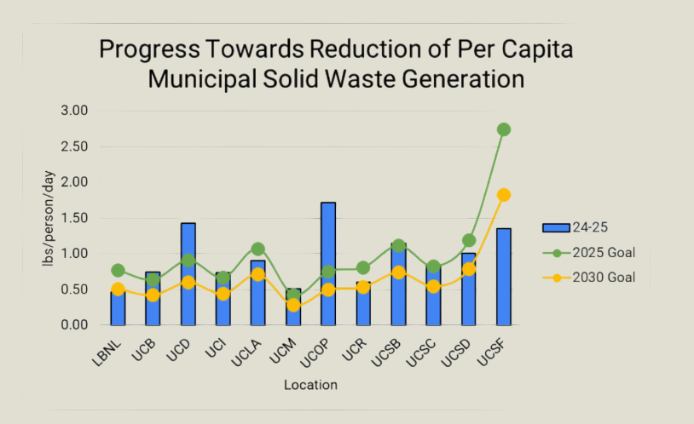

Scope of Work
This report will discuss various opportunities to reduce waste. Focus areas include UCD’s current waste generation and reduction efforts, waste reduction initiatives occurring at other University of California (UC) schools, and broader reduction strategies that are being employed by the UC Office of the President (UCOP). More specific focus areas include pilots for food waste and single-use reduction, education and engagement strategies, barriers to waste reduction, and recommendations for improvement.
This report will not focus on waste diversion efforts, such as waste sorting, composting, recycling, and any other strategies to divert waste from the landfill. Instead, this report proposes various ways to reduce the amount of waste that is generated in the first place.

Methodology
Our project’s quantitative data is limited to the years 2019 through 2024 due to the availability of greenhouse gas emissions and waste tonnage data. Trends in waste generation for the recycled, composted, and trash streams were charted based on data provided by the UCD Office of Sustainability. This data was also used to identify the top ten carbon dioxide (CO2)-emitting material types in the waste stream and calculate average CO2 emissions per waste stream. Beyond the raw quantitative data analyzed, many interviews were also conducted to gather valuable insight into how reduction efforts are playing out at UCD and across the UC system. Eight people were interviewed, including:
- Kelli Ann O’Day with the UC Davis Office of Sustainability to understand the current waste reduction strategies employed by UCD;
- Jasmine Aranda, who works for the Custodial, Grounds, and Waste Management branch as an Administrative and Waste Manager;
- Samuel Orellana, who is a sustainability advisor for student housing;
- Jen Bowser at UC Santa Barbara (UCSB), and Jade Goegebuer, who works at UC Los Angeles (UCLA), both of whom are cochairs of the systemwide Zero Waste Working Group;
- Agnes Martelet, who is the Associate Director of Sustainability for UCOP;
- Aarushi Gupta, a senior Sustainability Planner at UC Irvine (UCI);
- Lin King, who is the zero-waste campus manager at Campus Operations Facility Services at UC Berkeley (UCB).
Interview findings were then sorted into five major categories: 1) food waste and single-use reduction, 2) procurement reform and departmental resource sharing, 3) education strategies, 4) barriers, and 5) recommendations for improvement. This sorting methodology enabled a holistic understanding of waste reduction strategies by integrating perspectives from those who actively manage and handle it every day to more big picture goals and projects occurring UC-wide.

Equity
In our research, we focused on both procedural and distributive equity when evaluating waste reduction strategies on campus. Procedural equity concerns who is involved in decision-making and how systems are designed. For zero-waste initiatives to thrive, students, staff, faculty, and external stakeholders, such as policymakers, local businesses, and other universities, must be involved in the process of crafting waste reduction programs (Giurea et al., 2025). Our interviews with faculty and staff on the Davis campus and across the UC system were a crucial first step in ensuring procedural equity remains at the center of our project.
Distributive equity focuses on who benefits from and is impacted by these initiatives. As a result, accessibility was a key consideration throughout our analysis. For example, while reducing single-use plastics is an important goal, access to essential items such as straws must be maintained for individuals with disabilities who rely on them (University of California Office of the President, 2024). Similarly, alternatives such as water dispensers, refill stations, second-hand stores, and reuse systems must be convenient, affordable, and widely available, as these options can sometimes be difficult to locate or more expensive than their single-use counterparts (Rodríguez-Guerreiro et al., 2024).
We also considered the role of behavior and participation, as research shows that ongoing education and engagement are far more effective than one-time awareness campaigns (U.S. Environmental Protection Agency, 2026; Giurea et al., 2025). To understand the economic and environmental perspectives of waste reduction, we evaluated the costs and accessibility of waste reduction alternatives and examined how reducing landfill waste can lower greenhouse gas emissions and benefit surrounding communities.
Ultimately, successful waste reduction efforts must actively engage all campus stakeholders, incorporate accommodations that allow everyone to participate, remain easy and affordable to use, and demonstrate clear environmental benefits. By considering these equity dimensions, waste reduction strategies can be both effective and inclusive without creating new barriers for members of the campus community.

Findings

UCD Waste Trends
Since 2020, organic materials (composted tonnage) have become the largest waste stream, while recycling tonnage has dropped dramatically since 2020 (see Figure 3) (University of California, Davis, 2025a). However, total greenhouse gas (GHG) emissions and CO2 emissions per ton from the trash stream surpass those from the compost stream (see Table 1) (University of California, Davis, 2025a). Trash generation has also been gradually climbing following a dip in 2021 (University of California, Davis, 2025a).

Figure 3. UC Davis Waste Generation from 2020 to 2024, in Tons (University of California, Davis, 2025a).

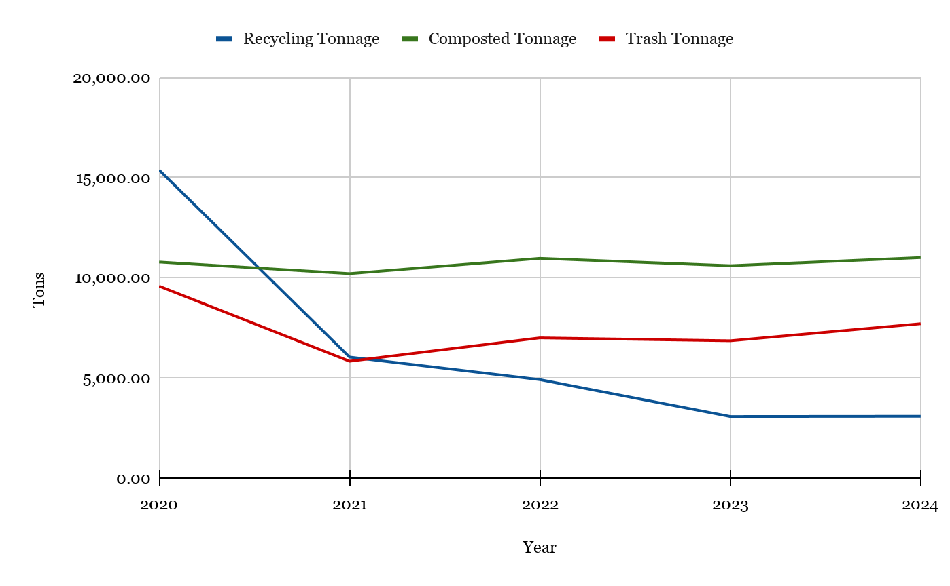
Table 1. Waste generation and corresponding CO2 emissions in 2024 (University of California, Davis, 2025a).
Waste Stream | 2024 Generation (Tons) | Corresponding Emissions (in MT CO2e) | Emissions (MT CO2e) per Ton
Recycling | 3,083.13 | 104.09 | 0.03
Composted | 11,003.38 | 1,426.49 | 0.13
Trash | 7,701.91 | 1,437.10 | 0.19
*Note that individual materials within these waste streams have differing emissions factors that contribute disproportionately to total corresponding emissions for a given stream. For a more detailed breakdown of the top 10 emitting material types based on emissions factor, see Table 3 in the Appendix.

If the Office of Sustainability chooses to target the waste stream with the highest tonnage, organic materials should be reduced first, followed by trash (i.e., Municipal Solid Waste), and finally recyclables. However, if considering landfill tipping fees and CO2 emissions, targeting the trash stream for reduction may yield more expansive benefits.
Determining the optimal reduction approach will first require an understanding of UCD’s current waste reduction initiatives, barriers to broader waste reduction, and opportunities for creating new or expanding upon existing waste reduction programs, processes, or educational initiatives. In crafting and implementing new approaches, UCD can draw on the successes of fellow UC campuses’ zero-waste initiatives, utilize funding provided at the UC systemwide or government levels, and receive support from environmentally driven on-campus student groups.

Waste Reduction at UC Davis
Interviews with campus stakeholders Jasmine Aranda (UCD), Samuel Orellana (UCD), and Kelli Ann O'Day (UCD) illustrate how UCD has primarily prioritized waste diversion over reduction. The campus has some robust diversion programs, such as its coordinated effort to recycle move-in and move-out waste and recover food from dining halls. In 2021, UCD also published a detailed action plan for getting to zero waste (University of California, Davis, 2021). However, many of the recommended approaches listed in the action plan have yet to be enacted. Shortcomings persist in UCD’s food waste and single-use reduction efforts, procurement policies, departmental resource sharing, and zero-waste educational initiatives. Specific waste reduction initiatives in UCD’s procurement processes could not be identified due to an inability to interview staff in this department. The following sections detail our interview findings.

Food Waste and Single-Use Items
UCD’s dining commons strive to recover or repurpose excess food produced by their kitchens. However, according to Samuel Orellana (UCD), no dining halls on campus have additional food waste reduction programs or gather sufficient data for tracking food waste beyond occasional audits. As a result, students are not being engaged in the process of reducing their food waste, and dining commons lack visibility into the types of foods that students are commonly discarding.
Compared to food waste reduction efforts, UCD has been more involved in eliminating single-use plastics on campus and implementing reusable and compostable foodware and to-go containers at dining halls. Samuel Orellana (UCD) noted how UCD’s ban on single-use plastics has been a recent success. The school has completely banned plastic bags and instituted partial phaseouts of plastic foodware and beverage bottles at campus dining facilities, third-party dining facilities, and vending machines (University of California Office of the President, 2025). Dining retail locations are being increasingly pushed to switch to compostable foodware.
Reusables are also gaining traction on campus. Dining areas, such as the Memorial Union, are utilizing reusable containers, while additional digital deposit-and-refund reuse pilots are being spearheaded at the student-run Coffee House (CoHo) on campus (Easley, 2026). UCD’s Embrace Reuse program and Reusable Utensil Implementation Pilot Program have focused on distributing reusable utensil kits to students, staff, and faculty (UC Zero Waste Working Group, n.d.). While these pilots are generating momentum for reusables on campus, these programs will need to be scaled up and broadened to other dining halls and retail facilities on campus to generate significant impacts.

Recommendations for Food Waste and Single-Use Items
- Improve food waste tracking. UCD should conduct regular food waste audits in both dining halls and retail food locations. These audits could be as simple as weighing kitchen food waste at the end of each day. While this would not account for food waste generated by students, this method would be easy and inexpensive to implement while providing a better baseline for decisions to be made based on current dining patterns rather than assumptions.
  - Equity opportunity: Better tracking would help UCD identify which foods are being discarded while avoiding changes that could unintentionally reduce student access to food options.
- Expand source reduction strategies. UCD has already implemented trayless dining and, after improving food waste data collection, UCD could consider onboarding other source reduction strategies such as smaller plates or cost structure changes (Rodríguez-Guerreiro et al., 2024).
  - Equity opportunity: Cost structure changes could expand equitable access to food by charging students based on the amount of food they consume, rather than relying on a fixed charge that may impact students disproportionately (Rodríguez-Guerreiro et al., 2024).
- Expand reusable systems. Reusable systems are still limited to certain locations and are not yet universal across campus. Retail cafes and markets often rely on disposable packaging and prepackaged items. Because of this, retail locations should be prioritized when expanding reusable pilots beyond the dining commons.
  - Equity opportunity: Reusable systems only work if they are easy for all students, staff, and visitors to use. Programs that require extra time or knowledge may create barriers for people with mobility limitations, little familiarity with the campus, or a busy schedule (Rodríguez-Guerreiro et al., 2024).
- Prioritize ease of use. Return bins, convenient drop-off locations, staffing, clear instructions, and clear signage should be included when implementing reuse pilots to make these systems accessible across campus and enable participation.
  - Equity opportunity: Interviews with Agnes Martelet (UCOP), Jen Bowser (UCSB), and Jade Goegebuer (UCLA) suggest that reusable pilots can demonstrate the viability of alternatives to single-use items only when ease of use is prioritized. If reusable systems are confusing, inconvenient, or require too much effort, participation will be limited.
- Plan for reuse infrastructure. When considering the expansion of reusable programs, UCD should account for the extra labor, washing, storage, and return logistics needed to support the program.
  - Equity opportunity: Planning for these extra needs ahead of time or partnering with external organizations to fulfill these capabilities would help prevent reusable programs from being difficult for staff to manage or confusing for students and visitors to use.

Procurement and Departmental Resource Sharing
While our team was unable to contact UCD staff responsible for procurement decisions and departmental resource sharing, our interviews with stakeholders at other UC campuses have allowed us to identify common barriers and opportunities for waste reduction at the procurement level that may apply to UCD.
A significant amount of waste generated on campus is created before students or staff even use a product. Interviews with Agnes Martelet (UCOP) and Aarushi Gupta (UCI) stress that sustainable procurement practices are crucial for enabling campuses to prevent waste upstream instead of only managing it downstream.

Recommendations for Procurement and Departmental Resource Sharing Reform
- Create guidelines that restrict purchasing products with unnecessary packaging or non-reusable materials. These guidelines could also encourage the selection of lower-waste alternatives.
  - Equity opportunity: Changes to procurement policies should not be created without input from the specific departments that use these products. Interviews with Agnes Martelet (UCOP) underscored how procurement can be challenging to reform because of the unique needs of various departments, labs, dining units, and offices. This is an equity issue because departments, labs, offices, dining, and custodial staff may experience procurement changes differently (Giurea et al., 2025). Involving these groups before adopting new purchasing rules would help UCD reduce packaging waste without creating new burdens for the people who rely on or manage them. Before enforcing stricter rules, UCD should investigate what packaging waste has reasonable alternatives and can be reduced without affecting functionality.
- Increase bulk purchasing to reduce repeated shipping and packaging waste.
  - Equity opportunity: UCD would first need to establish clearer procedures for resource sharing across departments in order to identify shared needs, combine orders, and reuse excess materials before ordering new items.

Education and Coordination
While the UCD Office of Sustainability conducts outreach and holds events to address zero waste on campus, current educational efforts are being undermined by inconsistent waste management infrastructure and infrequent waste reduction messaging.
Jasmine Aranda (UCD) emphasized that UCD has inadequate and inconsistent signage on its waste bins that make effective material sorting difficult, resulting in high contamination rates for the recyclable and compostable streams. The highest contamination rates can be seen in student housing and dining halls.
Nonstandardized bins further add to the confusion around proper waste management. Departments and buildings can purchase their own bins without consulting custodial services and may opt out of providing compost bins under the justification of higher costs. As a result, the types of bins available throughout campus are inconsistent, and the option to properly dispose of compostable materials may be entirely lacking for students, faculty, and staff, depending on their building. Jasmine Aranda (UCD) noted how the Facilities team is attempting to acquire funding to standardize the waste bins located outside of every building on campus, including student housing and dining commons. While these inconsistencies more directly impact waste diversion rather than reduction, they signal to campus stakeholders that UCD currently has a nonuniform approach to tackling waste, making current waste reduction goals harder to accomplish.
Infrequent waste reduction messaging is also detracting from UCD’s push for zero waste. UCD conducts most of its zero-waste education in the fall to inform incoming students. The Office of Sustainability takes advantage of tabling opportunities, such as Davis Fest, the Thank Goodness for Staff picnic, and the on-campus farmers market, to host a zero-waste game for students to improve awareness of proper waste sorting practices. At these events, the team also provides recycling and composting bins along with zero-waste guides. Water trucks have been brought in to encourage attendees to fill their own water bottles. These efforts help to inform event attendees of waste management best practices. However, the impact of these efforts remains limited to the events in which they are held. Without frequent messaging to constantly reinforce UCD’s zero-waste efforts, these educational initiatives will not be able to engage the broad audiences needed to change how campus stakeholders perceive and address waste reduction.
Lastly, there is an overarching lack of accountability for implementing and managing UCD’s zero-waste action plan. Without a Zero-Waste Coordinator, the responsibility for enacting waste reduction initiatives is diluted across a broad range of departments, all of which have differing and potentially competing priorities. Given the inherently dispersed nature of waste management and the lack of building-level waste audits, the largest waste generators on campus remain difficult to pinpoint and engage.

Recommendations for Improving Education and Coordination
- Improve coordination by designating a full-time Zero-Waste Coordinator. This staff member would be the point of contact and facilitate departmental coordination for campus reduction efforts. A Zero-Waste Coordinator could track progress, support grant applications, organize waste audits, and launch new initiatives. This would make current efforts more consistent and uniform across campus.
  - Equity opportunity: A Zero-Waste Coordinator would ensure that departments are not left to decipher changes on their own. Without a point of contact, departments with more resources, such as staff, funding, or sustainability knowledge, may be better able to participate, while other departments may fall behind. A Zero-Waste Coordinator could help clarify expectations and provide support across all campus units.
- Improve education by building waste education into daily life for students, staff, and faculty to promote long-term behavior change. UCD should use regular campus newsletters, student housing emails or newsletters, student organization partnerships, consistent campuswide bin signage, and orientation materials offered through Canvas to make waste reduction more visible.
  - Equity opportunity: Education initiatives should be designed to reach people in multiple ways rather than only relying on voluntary tabling events or one-time orientation materials (Giurea et al., 2025). Students, staff, and faculty interact with campus waste systems differently, so education should be frequent, easy to understand, and visible in the places where waste is generated.

Waste Reduction Across the UC System
UCD can draw inspiration, learn best practices, and identify pitfalls from other UC campuses that are pursuing waste reduction initiatives when deciding upon zero-waste programs and processes to implement on campus. A host of waste reduction initiatives are being spearheaded across the UC system to meet the individual campus waste reduction goals established by the UC Policy on Sustainable Practices. Efforts range from pilots that address food waste and single-use plastics to new educational and engagement strategies intended to spur campus-wide participation in waste reduction.

UC Pilots: Addressing Food and Single-Use Plastic Waste
Food Waste
According to Agnes Martelet (UCOP), UCLA is taking a comprehensive approach to addressing food waste by conducting quarterly front- and back-house waste audits to identify common waste sources. The campus is also changing how meals are served at its dining halls to reduce overconsumption by providing smaller plates and shifting to trayless dining. However, UCLA has had to change some of its kitchen setups to accommodate this new model.

Refill and Reuse
Many UC campuses are making strides in their attempts to implement reuse systems to eliminate single-use plastic packaging and foodware.
UC Berkeley’s Sustainable, Holistic, Accessible, Recoverable & Equitable (SHARE) Space, located in the Haas Business School, offers a Zero Waste Wonderfil Station where students, staff, and faculty can purchase detergent, soap, shampoo, and lotion using bring-your-own reusable bottles (UC Berkeley Haas, n.d.). Beyond this refill station, the SHARE Space is heavily focused on food recovery efforts, offering excess food to students and faculty in reusable containers (UC Berkeley Haas, n.d.).
UC Berkeley is also tackling waste at large events. Cal Athletics partnered with Cal Zero Waste, Levy, Pepsi, and r.World Reusables to reduce waste at its football games by distributing durable, reusable plastic cups to attendees (University of California Office of the President, n.d.). Clearly marked return bins were then set up on site for people to return their cups, which r.World Reusables then collected, sanitized, and returned to Cal Athletics for use at the next game.
As winners of the Single-Use Plastics (SUP) Policy Grant for 2024-25, other UC campuses are enacting pilots to eliminate plastic waste. These projects are demonstrating significant cost savings and reduction potential (UC Zero Waste Working Group, 2025). ASUCLA’s ‘Greenhouse’ Reusables and Return Station Pilot procured 2,000 reusable to-go containers and yielded savings of about $56,059, despite only a 30% reuse rate for these containers. The program diverted about 1,132 pounds of packaging waste from landfills, reducing waste management costs by $8,500. UCSF’s Reusable and Compostable Utensils Pilot Project at Moffitt Cafe has a projected savings of $24,275.49 annually, preventing the use of about 798,744 plastic utensils, equivalent to 19,370 pounds of waste, over the six-month project. The campus’s Reusables Pilot Project at Mount Zion Cafe also saw significant reductions of 31,584 disposables over six months, equivalent to 1,184 pounds of waste. The pilot is projected to save $2,983 annually.
Many other UCs are utilizing this grant funding to reduce packaging waste by switching to reusable containers for food recovery programs, installing new refillable beverage infrastructure, and pursuing additional reusable foodware projects. See Tables 4 through 6 in the Appendix for a full list of the winners and their project outcomes.

Lab Plastics
Lab waste was also identified as a major challenge for campuses by Agnes Martelet (UCOP) and Lin King (UC Berkeley). To tackle this issue, UC Berkeley has established a Zero Waste Lab Program, working with Polycarbin to repurpose recycled lab plastics back into new lab equipment (Polycarbin, n.d.). UCD also started a pilot project using Polycarbin that was funded by the Green Initiative Fund.
UCSB is taking an alternative approach to addressing the challenge posed by lab-generated plastic waste. The campus’s Facilitating Laboratory Optimization & Waste (FLOW) Project partners with Art From Scrap, a reuse store run by the Santa Barbara nonprofit Explore Ecology, to repurpose UCSB’s single-use lab plastics into art supplies for local schools, artists, and community programs (Hamm, 2025).

Procurement: Addressing Packaging Waste
Agnes Martelet (UCOP) discussed how significant improvements in waste reduction can be achieved through procurement reform. UC Berkeley and UCI are prominent campuses that are taking measures to prevent the creation of waste through their purchasing decisions.
Aarushi Gupta (UCI) mentioned how, through its Green Labs initiative, UCI labs are conducting block purchasing to reduce individual lab ordering frequency and redundancy. Agnes Martelet (UCOP) discussed how other campuses are embedding restrictions into their purchasing databases to limit the types of items departments can buy. For instance, UC Berkeley’s procurement system does not allow departments to purchase plastic water bottles.

Monitoring, Coordination, and Education
Beyond pilot programs, the UCs are embedding waste reduction efforts in daily campus life. UCSF Health is improving its waste generation monitoring and zero-waste roadmap planning through its partnership with Engie Impact to conduct in-depth waste audits of its medical centers (UCSF Office of Sustainability, n.d.). Individual units within UCSF can also request local, small-scale audits of their waste bins. Agnes Martelet (UCOP) noted how UCSF is also piloting automatic Artificial Intelligence (AI) sorting at waste bins throughout campus to reduce contamination.
UCI is notable for its efforts to increase campus stakeholder participation in zero waste through interactive educational initiatives. EarthReps Ambassadors, or “Trash Talkers”, are deployed at Student Affairs events to help attendees sort their waste (UC Irvine Student Housing Sustainability, n.d.). These students also support annual campus waste audits. Aarushi Gupta (UCI) described how UCI paid students to develop a required online orientation module to teach new students how the campus handles its waste. Additional zero-waste trainings are being implemented through UCI’s Climate Action and Adaptation Plan. UCI’s custodial services are increasingly using pictures on their waste bin signs to ease the sorting process for students and staff.
UCI also implements a number of grassroots reuse initiatives to improve resource sharing across the campus. The campus’s donation bins, bike recycling program, student-run Discord Marketplace, Zot Exchange thrift store for Graduate Students, and library technology lending service provide avenues for students to give their used items a second life.
While many of these initiatives are more tailored to diversion than reduction, establishing thorough waste monitoring systems and creating a campus culture that promotes mindfulness of waste management are crucial for laying the groundwork for a zero-waste campus.

Funding and Support
Tapping into existing funding opportunities and additional sources of support, such as student groups, will be crucial for enabling UCD to tackle zero waste on a larger scale. The following are resources that exist at the broader UC-systemwide and governmental levels:
- University of California Office of the President (UCOP). The Global Climate Leadership Council group at UCOP comprises various UC faculty and administrative leadership who provide direction on systemwide sustainability goals. This group allocates funding for mini-grants to campuses, such as the UC Zero Waste Working Group’s Single-Use Plastics Policy Grant, from which UCD has already received funding for several reusable utensil pilots.
  - Additional tools. A systemwide contract was approved with Zabble, a waste auditing tool that helps identify contamination issues and provides more accurate, granular information on the material types commonly found in the waste stream. Zabble also helps describe the types of waste that belong in a given stream. The tool is currently being used by UCSF and UCSD.
- State government grants. California Climate Investments’ Reuse Grant Program funds the replacement of single-use containers, food service ware, and packaging with durable, reusable products (California Climate Investments, n.d.). CalRecycle’s Edible Food Recovery Grant Program supports new or expanded food waste prevention projects in California (CalRecycle, n.d.). Public universities and UCs are eligible for both grants.
Lastly, student groups provide a rich opportunity for advancing UCD’s zero-waste goals by encouraging broader student participation in developing and implementing new waste reduction programs, policy changes, and educational initiatives. CalPIRG, ASUCD’s Campus Center for the Environment, and the Zero Waste and Sustainability Club, among others, are potential partners to engage in these efforts (ASUCD Environmental Policy and Planning Commission, n.d.). The UCD Office of Sustainability could also recruit student assistants or volunteers to help lead research into or develop programs to identify additional opportunities for and barriers to waste reduction on campus. Since students are UCD’s largest stakeholder group, their support and enthusiasm will be crucial for bringing new zero-waste programs to life.

Appendix

Table 2. UC Davis Waste Generation from 2019 to 2024, in tons (University of California, Davis, 2025a).
Waste Stream | 2019 | 2020 | 2021 | 2022 | 2023 | 2024
Recycling Tonnage | 70,361.31 | 15,373.10 | 6,038.69 | 4,910.62 | 3,070.81 | 3,083.13
Composted Tonnage | 12,955.59 | 10,781.45 | 10,202.80 | 10,965.79 | 10,598.39 | 11,003.38
Trash Tonnage | 15,234.70 | 9,577.66 | 5,830.76 | 6,997.82 | 6,851.37 | 7,701.91
Total | 98,551.60 | 35,732.21 | 22,072.25 | 22,874.23 | 20,520.57 | 21,788.42

Table 3. UC Davis Top Ten CO2-Emitting Waste Material Types (University of California, Davis, 2025a).
Material Type | EPA Classification | Stream | CO2 Emissions Factor | Tons Disposed (2024)
Scrap Metal | Mixed Metals | Recycled | 0.23 | 0.00
Library Metal | Mixed Metals | Recycled | 0.23 | 19.16
Gloves (Kimberly Clark & Polycarbin) | Mixed Plastics | Recycled | 0.22 | 0.18
Polycarbin (Pipette Tip Boxes) | Mixed Plastics | Recycled | 0.22 | 0.20
Biodigester Waste | Mixed Organics | Trash | 0.22 | 11.56
Landfill | Mixed MSW | Trash | 0.2 | 7,260.74
Housing Landfill | Mixed MSW | Trash | 0.2 | 0.05
Landscape, Yard Waste | Yard Trimmings | Composted | 0.14 | 1,410.42
Manure and Shavings | Mixed Organics | Composted | 0.13 | 1,685.83
Animal Science Bedding | Mixed Organics | Composted | 0.13 | 7,186.61

Table 4. Scaling Reusable Food Recovery, SUP Policy Grant Winners (2024-25) (UC Zero Waste Working Group, 2025).
Pilot | Description | Results
Food Recovery Containers for Miramar Food Pantry, UC Santa Barbara | 1,440 reusable to-go containers purchased. | Prevented the use of about 550 to 750 single-use plastic containers, resulting in cost savings of around $250 to $300, which are projected to increase over time.

Table 5. Investment in Reusable Containers, Cups, and Utensils, SUP Policy Grant Winners (2024-25) (UC Zero Waste Working Group, 2025).
Pilot | Description | Results
ASUCLA ‘Greenhouse’ Reusables and Return Station Pilot, UC Los Angeles | 2,000 reusable to-go containers purchased. | Savings of about $56,059, even with only a 30% reuse rate for the reusable to-go containers. About 1,132 lbs of packaging waste were diverted from landfills, resulting in an $8,500 reduction in waste management costs.
Embrace Reuse Campaign, UC Davis | 1,480 reusable utensil kits were purchased and distributed to students, staff, and faculty. | Estimated annual savings of $231.
North District Market Reusable Container Pilot Program, UC Riverside | 500 to-go containers piloted at one dining facility. | With the reuse of 470 out of the 500 reusable containers initially distributed, 51.6 lbs of packaging waste were avoided, and 0.093 tons of corresponding CO2 emissions were reduced.
Reusable and Compostable Utensils Pilot Project at Moffitt Cafe, UC San Francisco Health | Compostable to-go utensils and reusable utensils for dine-in. | Prevented the use of about 798,744 plastic utensils over the six-month pilot project (~19,370 lbs of waste reduced). Projected savings of around $24,275.49 annually, with cost reductions in procurement of disposable items and waste disposal fees.
Reusables Pilot Project at Mount Zion Cafe, UC San Francisco Health | Transitioned to 20% reusable dishware. | Estimated waste reduction of 31,584 disposables over six months (~1,184 lbs of waste reduced). Projected annual savings of $2,983, with cost reductions in procurement of disposable items and waste disposal fees.
Reusable Utensil Implementation Pilot Program, UC Davis Health | Over 3,300 reusable utensil kits were distributed to staff. | Nearly 9,000 fewer single-use plastic utensils were purchased compared to the previous year, resulting in about $400 in cost savings.

Table 6. New Beverage Infrastructure, SUP Policy Grant Winners (2024-25) (UC Zero Waste Working Group, 2025).
Pilot | Description | Results
Banana Joe’s Soda Fountain Ice Machine, UC Santa Cruz | Replaced disposable to-go bottles with a Pepsi Foundation drink machine. | Eliminated about 8,000 plastic bottles a month.
Commencement 2025, UC Santa Cruz | Provided water refill stations at commencement. | Reduced about 500 to 750 single-use water bottles and about 15 five-gallon plastic water jugs.

Bibliography
- ASUCD Environmental Policy and Planning Commission. (n.d.). UC Davis Environmental Campus and ASUCD Organizations . Retrieved June 5, 2026, from https://eppc.ucdavis.edu/environmental-organizations
- California Climate Investments. (n.d.). Reuse Grant Program. Retrieved May 31, 2026, from https://www.caclimateinvestments.ca.gov/pilot-reuse-grant-program
- CalRecycle. (n.d.). Edible Food Recovery Grant Program. Retrieved May 31, 2026, from https://calrecycle.ca.gov/funding/foodwaste/
- Easley, J. A. (2026, January 5). UC Davis Introduces Reusable Containers . https://www.ucdavis.edu/news/uc-davis-introduces-reusable-containers
- Giurea, R., Tulbure, A., Popescu, L. G., Adami, L., Ragazzi, M., & Rada, E. C. (2025). Fostering sustainability: integrating circular economy practices to manage plastic waste in universities. Journal of Physics: Conference Series, 3028(1), 012018. https://doi.org/10.1088/1742-6596/3028/1/012018
- Hamm, K. (2025, August 6). Environmental leadership program launches lab plastics reuse and recycling. https://news.ucsb.edu/2025/021982/environmental-leadership-program-launches-lab-plastics-reuse-and-recycling
- Polycarbin. (n.d.). Sustainable Lab Solutions. Retrieved June 5, 2026, from https://polycarbin.com/?srsltid=AfmBOooAGg3R3EpmqAbMlJK-ssMhhqIF5DNfPxcHuRgIbYc7ikYguxZ3
- Rodríguez-Guerreiro, M.-J., Torrijos, V., & Soto, M. (2024). A review of waste management in higher education institutions: the road to zero waste and sustainability. Environments, 11(12), 293. https://doi.org/10.3390/environments11120293
- UC Berkeley Haas. (n.d.). SHARE@Haas Program. Retrieved June 5, 2026, from https://haas.berkeley.edu/sustainability/campus-sustainability/share-haas-program/?_gl=1*1wj9kxb*_gcl_au*Mjc2NjQ2NjA2LjE3NzkyNTMzNjI.*_ga*MzExMDAzMDAwLjE3NzA4NzQ1NzQ.*_ga_EW2RSBHHX6*czE3NzkyNTMzNjIkbzEkZzEkdDE3NzkyNTM1NzEkajU4JGwwJGgw
- UCI Student Housing Sustainability. (n.d.). EarthReps. Retrieved June 5, 2026, from https://sites.uci.edu/housingsustainability/earthreps/
- UCSF Office of Sustainability. (n.d.). UCSF Health Waste. Retrieved June 5, 2026, from https://campuslifeserviceshome.ucsf.edu/sustainability/ucsf-health-waste
- UC Zero Waste Working Group. (n.d.). SUP Policy Grant - Phase 1 (24-25) Project Results. Retrieved May 30, 2026, from https://docs.google.com/document/d/1SiYl0hZhiQWIC5XdaeRIVqXp6KjKFD0GtFTX9p4_NAw/edit?tab=t.0
- University of California, Davis. (2021, September). Getting to Zero Waste: An Action Plan for the Davis Campus. https://ucdavis.app.box.com/s/hq1ew4qovvjy1z2mzv0ipxrnov5c4lsu
- University of California, Davis. (2025a). UCD Main Campus Scope 3 Waste Emissions. https://ucdavis.app.box.com/file/2205530917898?s=ddjtpg2cgg59qwfg4gu7482hosdrhzpm
- University of California, Davis. (2025b). Zero Waste Summary 2024-2025. https://ucdavis.app.box.com/file/2204483555061?s=l9mggom7uywf2e5wwxk1m7lz9b86zkwi
- University of California Office of the President. (n.d.). Reusable Cup Collaboration Brings Cal Closer to Zero Waste - Sustainability Annual Report 2025. Retrieved June 5, 2026, from https://sustainabilityreport.ucop.edu/2025/2025/09/19/reusable-cup-collaboration-brings-cal-closer-to-zero-waste/
- University of California Office of the President. (2024). University of California Policy on Sustainable Practices. https://policy.ucop.edu/doc/3100155/SustainablePractices
- University of California Office of the President. (2025). University of California 2025 Sustainability Annual Report. https://www.ucop.edu/sustainability/_files/awards-and-rankings/2025-uc-annual-sustainability-report.pdf
- U.S. Environmental Protection Agency. (2026, January 15). Contract Language Case study: San Francisco. Transforming Waste Tool. https://www.epa.gov/transforming-waste-tool/case-study-san-francisco

