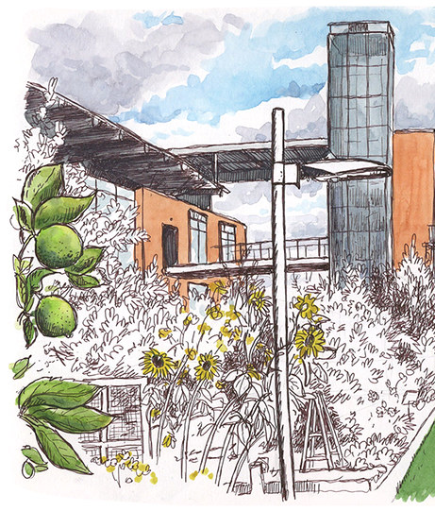

Prototype Testing of the Mondavi Winery Wastewater Pretreatment
Final Report
ABT 212: Path to Zero Net Energy
Miguel Craven, Daphne Lee, Brooke Threlkeld
Client: James Nelson, Alexandra Malm
Date: June 9, 2026

Table of Contents
Executive Summary 1
Project Background 1
Brief history and context for project and client 1
Problem description 2
Objectives 3
Relevant prior art/literature review 3
Methodology 4
System Design 4
Major considerations, constraints, assumption and metrics 5
Equipment & procedure 5
Analysis 6
Steps taken to address equity in project process 6
Results/Discussion 6
Main results relevant to the scope 6
Sources of uncertainty 8
Discussion of equity implementation successes and challenges 8
Recommendations/Conclusions 9
Future work 9
Addressing Additional Equity Challenges 9
Bibliography 10

Executive Summary
Wine production produces 9.25L of wastewater per 1L of wine produced (Bolzonella et al., 2019). This wastewater is generated throughout the winemaking process and is high in organic matter. Currently, the wastewater generated at the Robert Mondavi Institute (RMI) Winery exceeds the allowable organic matter concentration allowed for the UC Davis Wastewater Treatment Plant (UCD WWTP). In 2025, the RMI Winery introduced a vermiculture wastewater pretreatment system to reduce the organic content before being sent to the UC WWPT; however, the system failed due to its ineffectiveness at reducing organic matter to an acceptable level. Additionally, the worms in the system starved when the system was inactive.
This year, the RMI winery collaborated with ABT 212 to replace its vermiculture system with a traditional bacteria-based pretreatment system. The project client, James Nelson, tasked our project team with building the pretreatment system and designing and executing a testing protocol to test its effectiveness. Our team spent a week building the system with James's support. Afterwards, we conducted 3 weeks of COD, TOC, and BOD testing using Hach test kits.
Our results found a 62.62% efficiency rate in removing organics. Fluctuations in wastewater loading from other UCD facilities prevent the UCD WWPT from providing a single organics level standard, so it is unknown at this time whether this reduction is adequate. Conversations with the UCD WWPT are needed to determine whether this meets the UCD WWPT’s standards. One possible improvement to increase the efficiency rate is to add moving biofilm bed reactor (MBBR) media filters to the tanks. MBBR provides surface area for the system’s bacteria to grow on and prevents the bacteria from washing out of the system.

Project Background

Brief history and context for project and client
The Robert Mondavi Institute (RMI) is a teaching and research facility on the UC Davis campus that educates students on the wine-making process. The RMI generates over 500 gallons of wine annually (Quinton, 2025). However, its wine production generates wastewater high in organic matter, prompting the RMI to implement a pretreatment system to remove it before sending the wastewater to the UCD WWTP. In 2025, a cohort of ABT 212 students implemented a vermiculture pretreatment system for the RMI. The system fed wastewater through a series of three tanks that contained mulch and worms. The worms would break down the organic matter, while the treated wastewater would flow to a sewage drainage system. Unfortunately, this system did not treat the wastewater effectively. The system needed to be manually turned on and off, which was time-consuming. Additionally, while the system was inactive, the worms were not fed and died. To correct this, a new bacteria-based system was introduced. The clients for this project were James Nelson and Alexandra Malm. The main client for this project, James Nelson, is the RMI’s Sustainability Engineer. Meanwhile, Alexandra Malm is an Engineering Project Manager with UC Davis Facilities. She has been involved with the RMI’s pretreatment system journey and has provided guidance throughout the project.
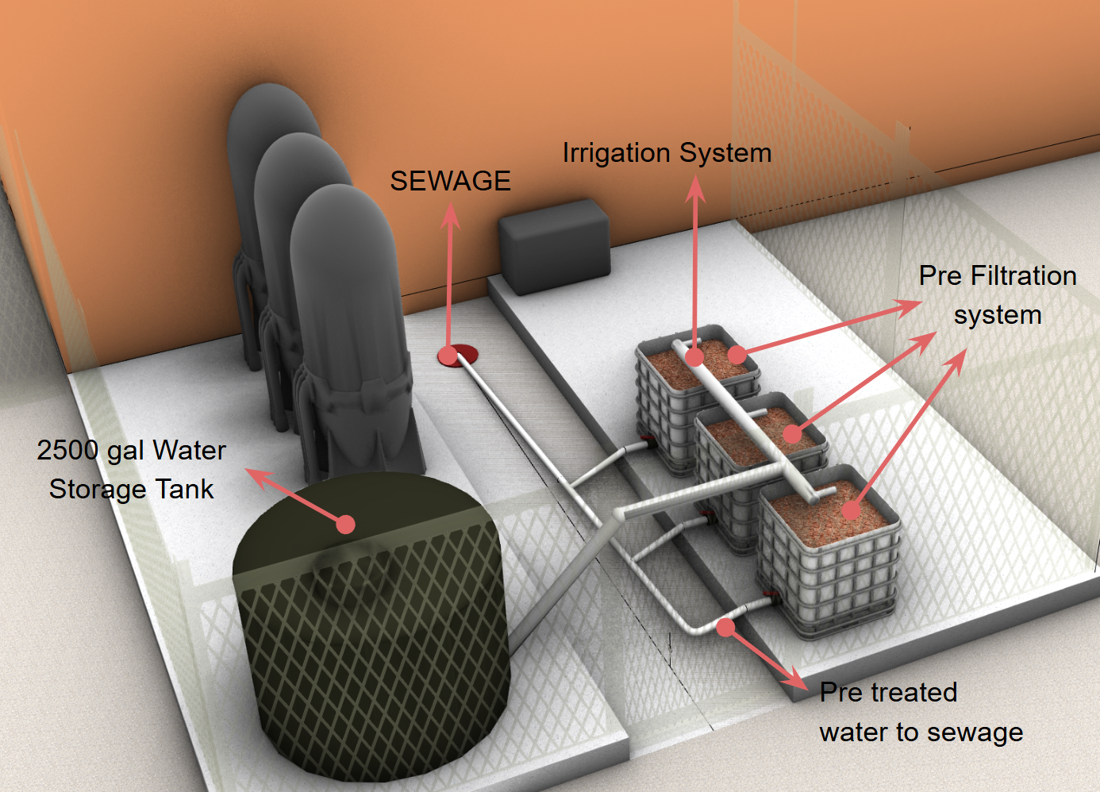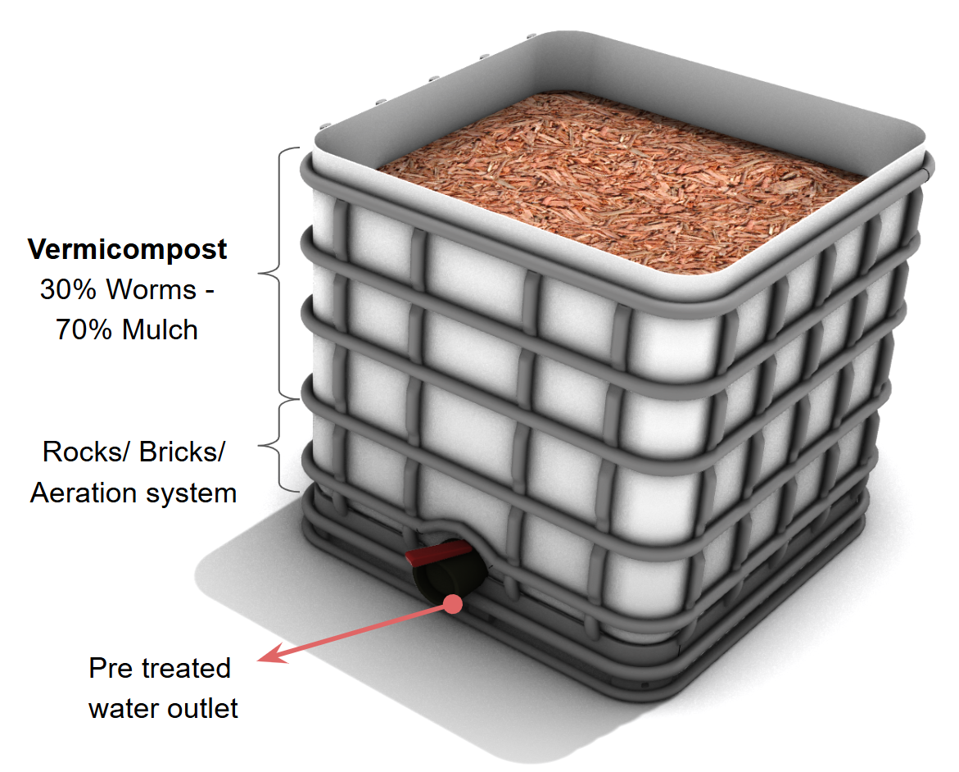
Figure 1: Model of previous vermiculture pretreatment system at the RMI site (left), vermifilter closeup (right)

Problem description
For every bottle of wine consumed, 9.25 bottles of wastewater are generated (Bolzonella et al., 2019). As shown in Figure 2, wastewater is produced in all stages of the production process (Saraiva et al., 2019). The Robert Mondavi Institute produces wastewater throughout the year. However, the winery sees its greatest wastewater load during harvesting season. The wastewater produced comes from vinting, bottling, and washing winery equipment (i.e. storage tanks).
Winery wastewater is high in organic matter and is typically quantified in terms of COD (Bolzonella et al., 2019). The high organic content in wastewater is burdensome to wastewater treatment facilities. Wastewater treatment plants, such as the UC Davis Wastewater Treatment Plant (UCD WWTP), use aerobic processing steps to remove organic matter from wastewater. When there is a large influx of wastewater from the winery, the high organic level overwhelms the capacity of the system. The wastewater depletes the available oxygen, and the wastewater treatment is unable to break down the organic matter in the wastewater.
To combat this problem, California has implemented wastewater laws for wineries. At a state level, the California Regional Water Quality Control Board (CRWQCB) requires wineries to submit a Notice of Applicability (NOA), a technical document that provides information about the wastewater discharged and the pretreatment processes (CRWQCB). Meanwhile, the specific limits of organic material in wastewater are regulated at a local level.
The RMI Winery’s discharge is required to meet UC Davis WWTP criteria. However, there is currently no local discharge limit of organic matter outlined by the UC Davis WWTP (UCD WWTP). Additionally, since the Robert Mondavi Institute is part of UC Davis and the UC maintains independence from several State regulations, it is not legally required to adhere to these legal requirements. As a result, the UC Davis WWTP is requiring the winery to attempt to reduce the organic matter in their wastewater by any amount.
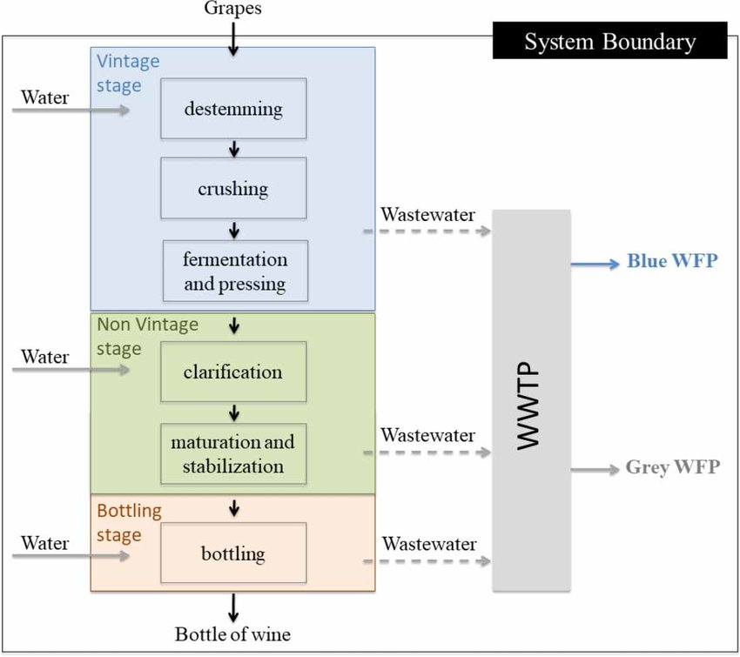
Figure 2. Wastewater generation through winemaking process (Saraiva et al., 2019)

Objectives
Our project team was tasked with replacing the RMI’s wastewater pretreatment from its initial vermiculture system to a bacteria-based pretreatment system. During our initial meeting, our client, James Nelson, tasked us with building the new bacteria-based system from the predetermined design. Additionally, we were tasked with researching, outlining, and executing a testing protocol to determine whether the system was effectively removing organic matter from the wastewater.

Relevant prior art/literature review
In our initial meeting with James Nelson, we were asked to center our literature review around researching small-scale pretreatment systems for wineries and researching common testing methods for small-scale wineries.
Our research into small-scale pretreatment systems identified two types of systems: anaerobic and aerobic systems (Bolzonella et al., 2019). Aerobic systems tend to be more efficient at removing organic matter. Meanwhile, anaerobic systems are still highly efficient and tend to be more cost-effective. As a result of their cost-effectiveness, anaerobic systems are more widely recommended for small-scale systems. The upgraded RMI pretreatment system is an aerobic system, which contradicts this opinion. However, the winery’s main goal is effectiveness, not cost efficiency. Additionally, the system reuses parts from the pretreatment system’s first iteration, which lowers the aerobic system’s high cost.
A case study from Litaor et al. (2015) tested the efficiency of a pretreatment system that consisted of four aerated tanks in series. The case study found the design was 90-95% effective. The pretreatment system of the RMI winery was identical to the case study’s design but included three aerated tanks instead of four. The researchers found that the fourth tank removed only 4% of organic matter. As a result, we predicted that our system would have a slightly lower efficiency of about 80%.
Our research also identified common testing protocols for assessing water quality. The three common testing methods for winery wastewater are COD, TOC, and BOD measurements (Aguilar-Torrejon et al., 2023). Chemical Oxygen Demand (COD) is the standard measurement of organic matter in wastewater and measures the amount of dissolved oxygen required to chemically oxidize matter. Biological oxygen demand is another common measurement of organic matter and measures the amount of oxygen demanded by microorganisms to break down organic matter over 5 days. Finally, Total Organic Carbon is the concentration of carbon bound to all organic matter.

Methodology

System Design
The proposed solution is a series of aerated tanks, a common wastewater treatment method for small scale wineries, chosen for its low cost and maintenance (Dombeck, 2005). The pretreatment system was designed by our client. Wastewater from the winery comes through to the 2500 gallon holding tank, which is connected to 3 IBC totes in series with gravity-assisted continuous flow. Dry microbes at dosing of 5 lbs / 750,000 gallons are added twice a week to the holding tank and the first two totes, with those tanks being aerated. The third tote acts as the clarifier with no aeration in order for the bacteria and solids to settle to the bottom to ensure the treated wastewater going to the sewage has minimal solids. Figure 3 below shows a diagram of the tanks setup.
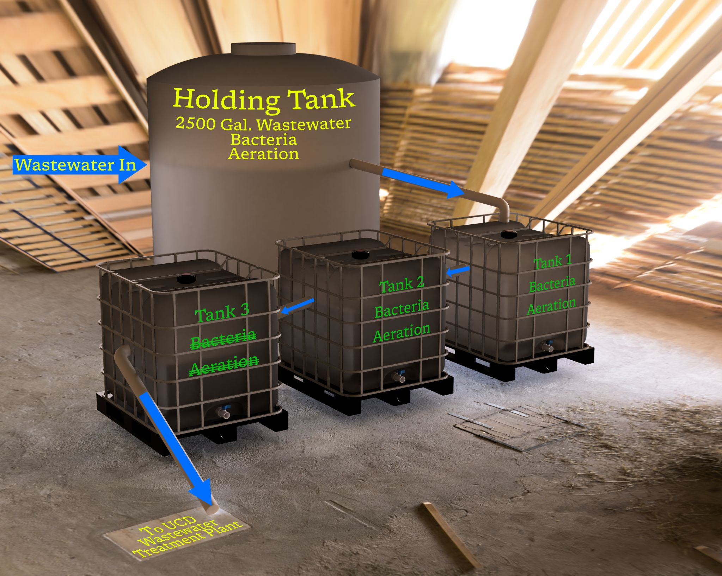
Figure 3. Model of pretreatment system
Aerobic Reaction of Bacteria
The facultative heterotropic bacteria will undergo aerobic respiration, consuming the organics in the wastewater as carbon source, and converting to energy to accumulate biomass, referred to as flocs, while releasing carbon dioxide (ClearBlu, 2016). The respiration reaction is as follows: $C_{6}H_{12}O_{6}+6O_{2}→6{CO}_{2}+6H_{2}O$. The bacteria requires no other nutrient addition.

Major considerations, constraints, assumption and metrics
Operational Seasonality
It is currently the off season for the winery, with the wastewater load being minimal and not highly concentrated. It is expected that during the vintage season (around late summer), the volume and organics level will increase significantly.

pH Variations of Wastewater
The winery wastewater is acidic due to the residual fermentation broth and cleaning agents while the bacteria requires a pH range of 6 to 10. To ensure the bacteria has an optimal environment to thrive, soda ash is added to the holding tank as a means of pH control.
Hydraulic Retention Time (HRT)
The system can be viewed as a configuration of CSTR (continuous stirred tank reactors) in series, with the aeration constantly mixing the wastewater. It is assumed that the reactors have non-ideal mixing since the geometry of the IBC totes can cause dead zones, lowering the effective volume of the tanks. Short-circuiting of the reactor will occur, with some wastewater exiting the tanks much faster and not getting treated. However, since there are three tanks in series, the non-ideal behavior can be alleviated. A nominal HRT can be calculated using the equation $HRT=\frac{V}{Q}$ where V is the total volume of the system and Q is the flow rate. The total volume of the tanks can be calculated as $\frac{2500}{2}+330+330*\frac{3}{4}+\frac{330}{2}=1992.5 gallon$, with the totes’ volume estimated by their capacity due to where the pipe connections in between them are. Hence, the volume capacity lowers to only half of the tank in the clarifier. The average flow rate of the wastewater is estimated as 250 gpd during off-peak season (Zoecklein, n.d.). However, it should be noted that based on the winery schedule, the flowrate would change due to the water usage. The nominal HRT is then calculated as $HRT=\frac{1992.5}{250}=7.97 day$. As the winery moves towards the vintage season, the flowrate of wastewater can increase to 1000 gpd, resulting in a HRT of around 2 days.
Dissolved Oxygen Delivery
Since the bacteria requires oxygen to survive, the wastewater must maintain a dissolved oxygen (DO) level of at least 2 mg/L. Currently, there are no means of monitoring the DO concentration in the tanks, and the air input is controlled by visual inspection of mixing of the tanks.

Equipment & procedure
Pretreatment System Equipment and Setup
The IBC totes are connected with bulkhead fittings and clear tubing, with each connection lower than the previous to allow for flow. The tanks are aerated with porous spargers installed on PVC pipes, placed through the opening at the top of the tanks. The dry microbes consist of a mixed culture of Bacillus and Pseudomonas microbes (ClearBlu Environmental). pH and temperature sensors are inserted for the holding tank.
System Operation
The pretreatment system operates continuously with minimal monitoring needed. The tanks were not sampled after the first addition of bacteria to observe effective treatment until one week later.

Analysis
Testing Protocol
Samples were taken prior to the addition of bacteria to evaluate the effectiveness of treatment. After the system was operating, samples were taken biweekly. 20 mL of samples were taken from all the tanks. Hach kits, COD Digestion Vials and TOC Reagent Set Test Kit (Hach®, Loveland, CO) were used for measuring the COD and TOC for each sample with replicates. The samples were stored in 4°C if testing could not occur on the same day of sampling. The results were interpreted using the percent reduction equation:
$$Percent reduction(\%)=\frac{starting value - ending value}{starting value}*100$$

Steps taken to address equity in project process
Emphasizing from the start the importance of developing a solution that would serve the community equitably, our group figured the best place to start would be with those at the end of the pipe. Having reached out to an engineer at the UCD WWTP, we discussed in a phone call what equity would look like to them in terms of this project. The greatest outcome of this conversation was the observation that the greatest equity this project could provide would be in the form of shifting the burden of treating the organic content from the distribution of rate payers that currently subsidize the winery’s increased load, and place it solely on the winery. We took this approach as our main guiding principle, and applied additional goals amongst our group, aiming to reach equity across three principles: restorative, procedural, and distributive equity. In doing so, we designed with the intent of preventing further environmental degradation while implementing circular irrigation practices, offloading the treatment burden to the winery, and sizing a system that would limit negative environmental impacts from overloading the WWTP.

Results/Discussion

Main results relevant to the scope
The team had three weeks to evaluate the system efficiency after completing the build. Figure 4 below shows the temperature and pH data of the holding tank. The temperature profile is expected due to the temperature variation throughout the day, with colder mornings and nights, and the hottest time around noon to afternoon. It can be seen that around 5/11, the pH started to increase from 4 to 5, which was when the bacteria was added. This is influenced by the soda ash addition to maintain the pH of the tank for the bacteria's survival. The pH continued to rise, which would be an indication of the acidic organic matter in the wastewater being broken down by the microorganisms.
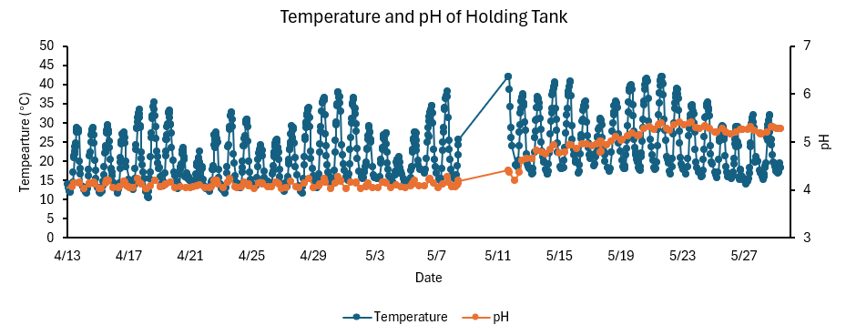
Figure 4. Temperature and pH data for the holding tank

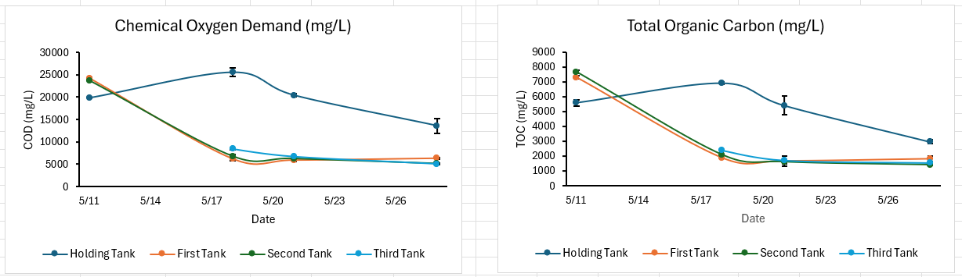
Figure 5. COD and TOC of all tanks in May, 2026
Figure 5 above shows the COD and TOC of the tanks for the sampled period. Both graphs follow a similar trend, with measured values reaching a plateau by the end of May. On 5/11, which is the baseline sample, the readings for both metrics were higher for the first and second tank as compared to the holding tank. A possibility could be due to during the startup of the system, there were solids settled at the bottom of the tanks which got stirred up when the aeration started; whereas the holding tank has been aerating for longer. This could lead to a higher initial total solid in the IBC tanks. The data in the holding tank briefly increased from 5/11 to 5/18, which could be due to solids built up at the sampling port. If there were more solids on 5/18 compared with 5/11, the COD and TOC readings would increase as the test kits would measure all organic matter in the wastewater including the solids portion. Our clients provided historical testing data on April 9th, 2026 showing the COD measured was at 29,900 mg/L. This value is slightly higher than the values first measured on 5/11. The winery was bottling on 5/21, which can have a dilution effect for the wastewater, as indicated by the decreased COD / TOC values in the holding tank. Bottling would not introduce a large amount of wastewater high in organics, but would mostly result in high volumes of rinse water. The rinse water would actually dilute the organics level present in the tanks.
Table 1. System performance evaluated by COD
Tank | 5/28 Stage-Specific Reduction (%) | Total System Reduction(%)
Holding Tank | - | 31.53
First Tank | 53.41 | 73.92
Second Tank | 18.97 | 78.40
Third Tank | 0.98 | 74.40
Overall System Efficiency | - | 62.62
Table 1 above shows the overall system performance. The stage-specific reduction refers to effectiveness of treatment from each tank on 5/28. The first tank showed the highest stage-specific reduction, most likely due to the high incoming organic matter from the holding tank. This also confirms the theoretical HRT of almost 8 days, as most of the organics were broken down at the first tank stage. Total system reduction measures the percent reduction in COD from the first to the final sample date for each of the tanks. The reductions for the three tanks are similar, while the holding tank shows the least reduction, which is expected due to being the first stage of pretreatment. The overall efficiency, at 62.62%, measures the effectiveness from the influent at the holding tank to the effluent at the third tank during the last sampled date, showing the efficiency of reducing organic matter when the pretreatment system is stabilized. We can determine the stability from the COD and TOC readings plateauing since 5/21.

Sources of uncertainty
There were several sources of uncertainty when testing the system. Human errors could occur when performing the Hach kit testing, mostly arising from dilution precision of the samples. Another source of error could come from the unrepresentative sampling of the tanks. Sampling for the holding tank was at the sample valve, which can have solids buildup. The IBC tanks were sampled from the top opening of the tank, but due to the water level height, the top portion of the tank could have a different organic profile than the bottom portion.

Discussion of equity implementation successes and challenges
Due to the difficulty in tracking the organic content reduction’s impact at the wastewater treatment facility and the facility’s lack of an organic content standard, we weren’t able to determine exactly how the pretreatment system contributed to equity. However, we can assume due to the findings of the overall efficiency of the tanks in reducing organic matter that this likely relieved the facility of a decent amount of workload previously brought on by the winery.
This success not only showcased the potential of an equitable system in the light of practicing and proving the feasibility of a low-cost, low-maintenance, and easy pretreatment system; the successes of this project primarily brought forward equity for the campus community through the cost shifting of placing this intensive activity on the winery instead of the wastewater treatment facility. This abatement for the treatment facility creates a more just cost model in which the other rate-payers are not bearing the costs of the winery’s burden. Despite the successes, challenges still lie ahead in verifying the true success of this pretreatment system in equitably shifting the burden onto the winery.

Recommendations/Conclusions

Future work
Maintenance of Pretreatment System
It is important to perform regular maintenance for the pretreatment system to maintain its productivity. A portion of the sludge from the clarifier, referred to as waste activated sludge (WAS), should be pumped and cleaned out periodically to avoid excess sludge buildup, which can cause ineffective oxygen transfer, resulting in the bacteria becoming anaerobic and dying. There should be dedicated DO probes for all tanks to monitor the system to ensure the air input amount is sufficient. Temperature control can be implemented for the tanks as well. Though the bacteria can tolerate a wide range of temperatures, their ideal thriving temperature is 37°C. Insulation or reflective material can be wrapped around the tanks or installed on the roof of the pretreatment facility to reduce the drastic change in temperature during the day. A testing meter can be purchased for instant and realtime measurements of COD in the wastewater to avoid high analysis test costs and long turnaround time.
Preparing for Vintage Season
During the vintage season of the winery, the wastewater volume and organic load will increase significantly. In preparation, the pretreatment plant should consider adding moving biofilm bed reactor (MBBR) media filters to the tanks. Bacteria would adhere to the surface area of the filters, creating a “biofilm”, a much more stable form of growth than free floating biomass flocs. This would provide resilience to high organic loading shock of wastewater. The filters ensure that each tank would have a healthy population of bacteria as they won’t be washed out immediately to the third tank with a higher volume of influent. The MBBR system has less sludge generation, and would also eliminate the need for return activated sludge system (RAS) to reduce the complexity of the system (Madan et al., 2022). RAS refers to having a portion of the sludge that can be pumped back into the holding tank as means to maintain the bacteria concentration and reduce lag phase growth. However, it should be noted that mesh needs to be installed at each of the pipe connections to ensure that the media filters don’t flow between tanks. Periodic inspection should be performed as well to make sure the filters are not clogging the mesh.

Addressing Additional Equity Challenges
Provided the suggestion of installing instruments to measure all of the organic content in realtime, this implementation would prove helpful in closing the ratepayer equity gap at the treatment facility. Using these probes, existing data of wastewater quality at other wineries, along with an analysis of organic content in wastewater standards at sewage districts across the state can help with the UCD wastewater treatment facility in developing a baseline target. This baseline target would prove extremely beneficial to all parties, being able to model and aim for targets, absolving the cost burden on other ratepayers. Further innovations can be made as well with local groups that may be affected by the wastewater runoff, such as the Putah Creek Council and the UCD Arboretum and Public Garden, which can give expert opinions and perspectives from the local ecosystem on how the winery can be stronger stewards of the local ecosystem.

Bibliography
Aguilar-Torrejón, J. A., Balderas-Hernández, P., Roa-Morales, G., Barrera-Díaz, C. E., Rodríguez-Torres, I., & Torres-Blancas, T. (2023). Relationship, importance, and development of Analytical Techniques: COD, BOD, and, TOC in water—an overview through time. SN Applied Sciences, 5(4). https://doi.org/10.1007/s42452-023-05318-7
Bolzonella, D., Papa, M., Da Ros, C., Muthukumar, A., & Rosso, D. (2019). Winery wastewater treatment: A critical overview of advanced biological processes. Critical Reviews in Biotechnology, 39(4), 489–507. https://doi.org/10.1080/07388551.2019.1573799
California Regional Water Quality Control Board. (2021, January 20). State Water Resources Control Board Order WQ 2021-0002-DWQ. https://www.waterboards.ca.gov/water_issues/programs/waste_discharge_requirements/docs/wqo2021-0002-dwq.pdf
ClearBlu Environmental. (2016). Dry Microbes Process Sheet. https://www.clrblu.com/wp-content/uploads/2024/06/ClearBlu-microbes-and-process-2016.pdf
Dombeck, G. (2005). Managing Your Wastewater Treatment Pond. WineBusiness Monthly. https://www.winebusiness.com/wbm/article/37013
Litaor, M. I., Meir-Dinar, N., Castro, B., Azaizeh, H., Rytwo, G., Levi, N., Levi, M., & MarChaim, U. (2015). Treatment of winery wastewater with aerated cells mobile system. Environmental Nanotechnology Monitoring & Management, 4, 17–26. https://www.sciencedirect.com/science/article/pii/S2215153215000045
Madan, S., Madan, R., & Hussain, A. (2022). Advancement in biological wastewater treatment using hybrid moving bed biofilm reactor (MBBR): A review. Applied Water Science, 12(6), 141. https://doi.org/10.1007/s13201-022-01662-y
Quinton, A. M. (2025, June 20). UC Davis launches small-batch wine label. Robert Mondavi Institute for Wine and Food Sciences. https://www.ucdavis.edu/food/news/uc-davis-launches-small-batch-wine-label
Saraiva, A., Rodrigues, G., Mamede, H., Silvestre, J., Dias, I., Feliciano, M., Oliveira e Silva, P., & Oliveira, M. (2019). The impact of the winery’s wastewater treatment system on the winery water footprint. Water Science and Technology, 80(10), 1823–1831. https://doi.org/10.2166/wst.2019.432
UC Davis Wastewater Treatment Plant. (n.d.). UC Davis local limits - sewer disposal policy. UC Davis Facilities. https://facilities.ucdavis.edu/sites/g/files/dgvnsk6436/files/inline-files/policy_1.pdf
Zoecklein, B. (n.d.). Winery Wastewater - Enology and Fermentation Science. Virginia Tech. https://enology.fst.vt.edu/downloads/wm_issues/Winery%20Waste%20Water.pdf

