Energy Investigator:
Making Energy Audits Beginner-Friendly

ABT 212 | Final Project Report

By Raymond Breault & Meena Venkatraman

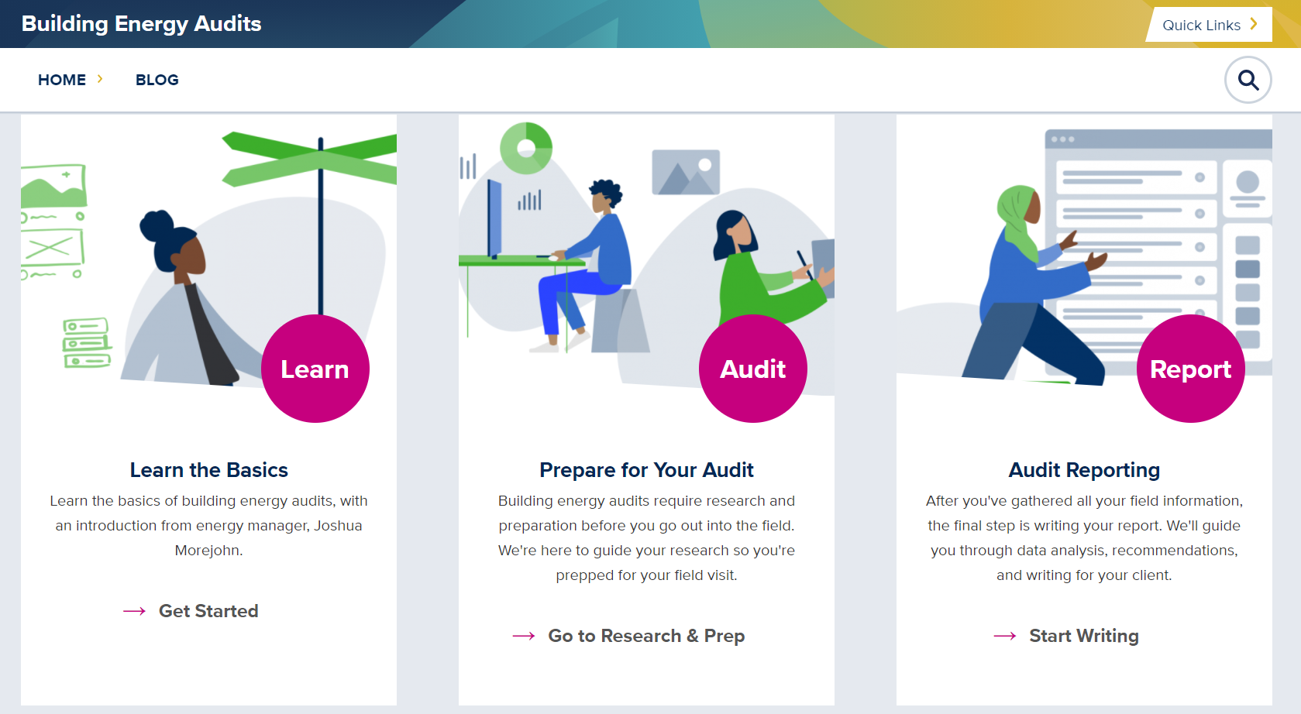

Table of Contents

Table of Contents 1
Project Background 2
History & Context 2
Problem Definition 2
Project Scope 3
Relevant literature review 3
Methodology 4
Website Feedback 4
Energy Audit 4
App Feedback 5
Writing Your Report 6
Results & Discussion 6
Website Feedback 6
Energy Audit 7
App Feedback 8
Writing Your Report 9
Recommendations & Conclusions 10
Recommendations 10
Conclusion 11
Bibliography 11

Project Background

History & Context
The Energy Investigator project originated as a project from the UC Davis Energy Conservation Office (ECO), headed by the project client Kiernan Salmon. ECO is concerned with reducing energy consumption and improving energy efficiency in campus buildings to help achieve UC Davis’ climate and energy goals, and energy audits help with these goals. Energy auditing is the process of examining a building’s energy usage with the goal of finding areas for energy conservation and efficiency improvements. Due to the complexity of an energy audit, typically only experienced professionals perform audits which can be prohibitively expensive for a building owner, and can be difficult to schedule, adding another layer of inaccessibility. While historically energy auditing has been restricted to solely professionals with years of experience, the Energy Investigator project aims to be unique in that it provides energy audit assistance at a level where people without any previous experience with energy engineering can follow along. This website acts as a bridge between energy professionals and energy novices searching for energy efficiency improvements. Target demographics for energy novices include UC Davis students, new hires at ECO, and property owners. The client requested the website be used in tandem with a third party app designed to improve energy audits by creating an easy to use program for documentation of all aspects covered in an energy audit site visit.

Problem Definition
The aim of the Energy Investigator project is to make energy auditing more accessible to people with varying backgrounds and levels of energy expertise who will take on the auditing process. Improving the accessibility of the energy audit training would help people learn how to conduct audits more easily, efficiently, and accurately. The accessibility of the energy audit process has been improved by evaluating a currently developed website for energy audit training and an app for recording energy audit information, as well as providing content for incomplete sections of the website.

Project Scope
The scope of this project includes website review and content development. The client’s requested deliverables included feedback on the main website, app feedback, and original written content to resolve any missing information on the website; to accomplish this, the use of the website as a guide for an energy audit at the UC Davis Heitman Staff Learning Center and its resulting report were added as part of the process for the deliverables. While the energy audit report is not a direct deliverable it is an important piece in the website review process and the report is intended to meet American Society of Heating, Refrigerating and Air-Conditioning Engineers (ASHRAE) I energy audit standards. Not included in the project scope is any coding for the website as there is a dedicated staff handling all coding and an additional team of students working on website layout and appearance. The scope of work for the third party app is feedback after use for an energy audit, but no original content is to be added.

Relevant literature review
Existing energy audit guides are usually in the form of long documents rather than easily navigable websites. While some of these are comprehensive and explain terms and concepts that would be unfamiliar to beginners, the format does not make the content easy to use for beginners [1][2][3]. The information that was available in a more concise format on websites did not provide much specific guidance, since it was usually in the form of an article [4][5]. No websites were dedicated completely to explaining energy auditing in a manner comprehendible to energy novices. Most website articles were only related to residential energy audits [6][7][8]. For commercial energy audits, there are some web-based tools available, but most are not free and require you to hire a consultant to use them [9]. Free web-based tools such as the Department Of Energy’s Audit Template are just for inputting audit information, performing calculations and exporting data, rather than guiding people through the audit [10][11].
Energy audit guides were used to inform website feedback and learn how to perform an energy audit. In addition, example energy audit templates for data collection provided by the client were used to better understand what information was needed during the site visit. To inform website content for the section on writing an energy auditing report, example energy audit reports and report templates were also reviewed.

Methodology

Website Feedback
The initial goal for website review was to compare it to other energy audit resources and then provide feedback on the website to address potential issues for the target audience of energy novices performing energy audits. Additionally, the website was used as the primary resource and guide to perform an energy audit on the UC Davis Heitman Staff Learning Center per the client’s request.

Energy Audit
The website was used to prepare for an audit at the client’s requested location and again to clarify how to analyze audit data after the building walkthrough. In addition to the client’s website, the Energy Investigator team reviewed professionally performed energy audits, other existing energy audit guides from sources such as the National Renewable Energy Laboratory and the Department of Energy. On May 3rd an energy audit was conducted at the UC Davis Heitman Staff Learning center using primarily the client provided website and app. The team met with the client, two of the client’s design interns, and one facilities manager who opened access to the building attic for inspection of the heating ventilation and air conditioning (HVAC) systems and water heater. The group then worked through the rest of the building using personal notes to record all relevant information which was then input to the provided app, and used cameras to take pictures.

App Feedback
The initial expectation was to use the app to record information during the energy audit site visit. However, during the site visit, taking notes on the floor plans was more convenient than inputting directly to the app. In order to still evaluate the app, the app was used to input audit information after the site visit, using the photos, notes and the floorplans to retrieve information. The app has a feature that allows the user to download a spreadsheet summary of the data, so the spreadsheets were downloaded to examine their usefulness for post-audit energy consumption calculations. During the process of writing the energy audit report, the team also noted the pieces of information that were convenient to retrieve from the app, such as the building’s age and square footage. Feedback on the app was provided in the form of notes and screen recordings. This feedback was shared with the client and design interns, who will use it to make further improvements.

Writing Your Report
During the energy auditing and report writing experience, the team kept documentation of the troubles and questions encountered along the way. In addition to this documentation, example energy audit reports and report templates were also helped to inform the website content for the ‘Writing Your Report’ section.

Results & Discussion

Website Feedback
Upon initial review of the website the most glaring issues were a lack of beginner level guidance and missing content. The website describes many useful aspects of the covered topics of HVAC, lighting, and building envelope but lacks beginner level guidance on how to find and properly compile the information a website user would need in the field. Another potential issue is the large amount of information provided with the expectation of complete comprehension before performing an energy audit.
The website also lacks guidance in its energy basics and energy data sections. While the sections perform satisfactorily in describing terminology, units, and potential patterns to look for, there is no guidance on how to handle or process data. Energy novices are unlikely to have experience manipulating energy data into appropriate scales and timeframes so there is insufficient guidance on how to turn the data into the form that can be appropriately analyzed. To prepare the data for analysis the website should include either example spreadsheets detailing how to turn data into the appropriate forms, or at the very least links to a spreadsheet software resource page where useful commands and calculations are explained.
The Energy Investigator website currently covers three energy topics: HVAC, lighting, and envelope. This excludes notable energy expenditures such as water heating, and plug loads. Water heating and plug loads account for nontrivial energy consumption in most buildings and as such should receive appropriate attention during an energy audit as well. To resolve this the website should add an additional sectional for miscellaneous loads not covered in the three existing areas covered.

Energy Audit
Unfortunately while on-site it became apparent that the website lacked applicable content on energy expenditures outside of HVAC, lighting, or building envelope. The audit was performed with the client’s website as the default resource but other resources were required to fill in missing information that was not covered in the main website, such as energy consumption of the building water heater and plug loads. Despite incomplete information on the website, the resulting energy audit report was able to provide multiple energy conservation and efficiency measures (ECMs), as in a typical audit, where measures are provided by the level of cost and investment. The zero-cost energy conservation measure provided was to manage plug loads, as workers had set up personal space heaters as well as unattended appliances. For low-level investments the building’s lighting systems could integrate daylight sensors to reduce excessive lighting, and fluorescent fixtures could be replaced with LEDs. Potential investment level measures include replacing the single paned windows with double paned, and replacing the current 30 gallon natural gas water heater with a tankless electric heater. Building energy usage was found to follow standard usage patterns; but the recorded HVAC energy consumption data provided indicated suspiciously low energy consumption compared to other expenditures. A more thorough energy audit of the Heitman Staff Learning Center was performed by another set of students who calculated the energy consumption based on nameplates and usage patterns, concluding that HVAC energy consumption was indeed too low in the reported data from the data loggers.

App Feedback
Feedback on the app mostly relates to its lack of flexibility for use during an actual site visit, since it was more convenient to take notes on floor plans than using the app.
One main missing feature in the app, similar to the website, is the lack of space to input information about plug loads or other miscellaneous loads, like there was for HVAC, lighting, and envelope features. The app has the capability to input occupancy schedule data and other useful information, however it still needs a section for inputting miscellaneous loads.
The spreadsheet format is difficult to understand and also does not currently ease the process of post-audit calculations. For example, it doesn’t collate the types and numbers of features in each room onto a single sheet, which would have been useful as a starting point for the post-audit calculations.
The app sometimes only lets the user add a building feature if all the description inputs can be completed, which doesn’t provide flexibility if a data point can’t be found during the site visit. It would also provide more flexibility to have a section for more general notes and questions that might not fit under a specific category.
The app overall seemed useful for storing important audit information but needs improvements for usability during an actual audit and more useful outputs for post-audit calculations.

Writing Your Report
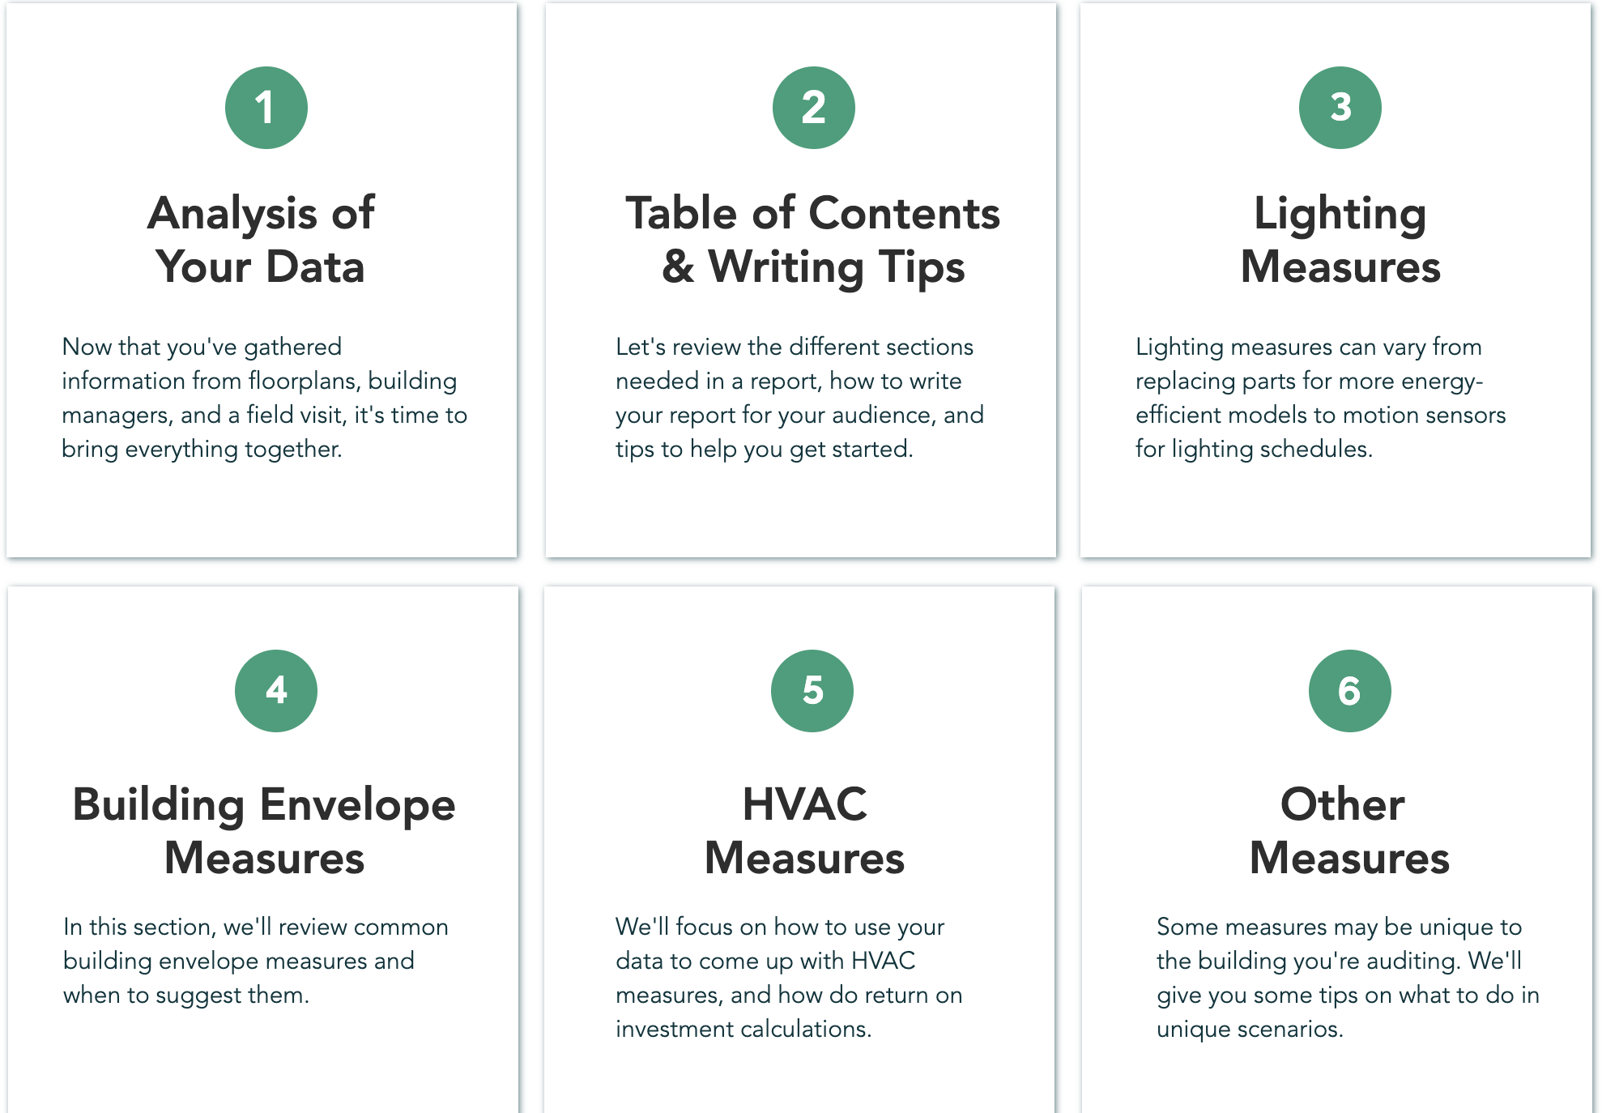
For the first “Analysis of Your Data” section, the team’s content provided guidance on what to do if the nameplate data needed to make savings calculations can’t be found during the audit site visit. Annotated example spreadsheets were also provided for how to convert HVAC data into monthly and hourly timeframes, and example spreadsheets with the team’s savings calculations for the ECMs proposed in the audit report. Apart from these spreadsheets, the added content explains how to do energy and simple cost savings calculations including simple payback years. Links were provided for where to find billing rates for both the campus and the average rates for cities in California.
Fig 1: Image of the “Writing Your Report” webpage showing the 6 categories

For the energy audit report, the structure was based on a template and example audit report provided by Ryan Stroupe from PG&E. In the “Table of Contents & Writing Tips” section, the template is provided, modified to be more relevant for an energy audit conducted by anyone rather than specific to PG&E. The template also includes information on what to write under each section.
The lighting section already includes information about why lighting measures matter, example ECMs, and brief instructions on how to write that section within the report. For this section, the team provided more specific guidance and links to other online guides for how to replace fluorescents with LEDs, based on the resources found when writing the audit report. For the other sections related to building features such as HVAC and building envelope, content was added on example ECMs, and how to calculate estimated cost and energy savings from these measures. New content included information about plug load and water heater ECM measures under the ‘Other Measures’ section, since these came up during the audit but information about them was lacking in the website.

Recommendations & Conclusions

Recommendations
The new website content was based on the team’s first energy audit experience; as such, energy professionals at ECO should review and edit the content before adding it to the website. They may also want to consider writing more content based on the feedback relating to other parts of the website apart from the ‘Writing Your Report’ section. Since outside energy audit guides were reviewed before the audit, another team of students should use the website as their sole resource to inform their audit process to truly evaluate the effectiveness of the website. The audience of the website is eventually going to be not just students, but also property managers and other professionals, so testing of the website should start with more people from these groups.

Conclusion
The website as it currently exists provides a useful starting point for people unfamiliar with energy audits. The main takeaway of this project is that the website needs to provide information in a more step-by-step manner so that the content is not overwhelming. For example, the website works best when succinctly summarizing information from other sources, rather than only providing links that people then have to look through. The other important aspect of step-by-step guidance would be including notes or helpful tips that could answer potential questions. With the feedback and recommendations provided, the website could become a great resource to guide and preemptively address issues that beginners might have while conducting energy audits.

Bibliography

[1] M. Baechler and C. Strecker, "A Guide to Energy Audits," Pacific Northwest National Laboratory, 2011. [Online]. Available: https://www.pnnl.gov/main/publications/external/technical_reports/PNNL-20956.pdf
[2] I. Shapiro, "Energy Audits in Large Commercial Buildings," vol. 51, ed. ASHRAE Journal, 2009, pp. 18-27.
[3] I. Shapiro, Energy Audits and Improvements for Commercial Buildings. Hoboken, New Jersey: John Wiley & Sons, 2016.
[4] T. Liou. "What is a Commercial Building Energy Audit?" GlobeSt.com. https://www.globest.com/sites/globest/2011/10/20/what-is-a-commercial-building-energy-audit/?slreturn=20210508135510 (accessed April 29, 2021).
[5] M. Frappier. "How a Commercial Energy Audit Works." EnergyLink. https://goenergylink.com/blog/how-commercial-energy-audit-works/ (accessed April 27, 2021).
[6] "Do-It-Yourself Home Energy Audits." US Department of Energy. https://www.energy.gov/energysaver/home-energy-audits/do-it-yourself-home-energy-audits (accessed April 29, 2021).
[7] J. Morell. "Slash Your Utility Bill with a DIY Energy Audit." This Old House. https://www.thisoldhouse.com/inspections/21017615/slash-your-utility-bill-with-a-diy-energy-audit (accessed April 29, 2021).
[8] M. Dilthey. "How to Do a Home Energy Audit." Solar Power Authority. https://www.solarpowerauthority.com/home-energy-audit/ (accessed April 27, 2021).
[9]"Level I & II Energy Audits." EMAT. https://www.ematprogram.com/audit-services/level-1-2-energy-audits/ (accessed April 27, 2021).
[10] "Audit Template." Office of Energy Efficiency & Renewable Energy, US Department of Energy. https://www.energy.gov/eere/buildings/audit-template (accessed April 22, 2021).
[11] M. D. Fisher, "EISA 432 Energy Audits Best Practices: Software Tools," Idaho National Laboratory, 2014. [Online]. Available: https://inldigitallibrary.inl.gov/sites/sti/sti/6270875.pdf

